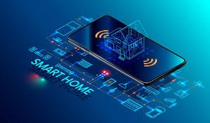

Smart Home

New technologies has changed our life, and make it easier and more comfortable.

One of this new technologies is Home automation. I like to call our system as smart home , not home automation , as I more wide and have no limits.

When we are talking about smart home, we split our system to some sub-systems.

- lighting system

- fire fighting

- door lock system

- widow system

- power consumption system

- monitoring system

- IOT

- etc..

This is the main systems and other come farther.

We are developing a new product and developing method

Our architect is a dynamic architecture and increment product.

We will start with ( Lighting system ) as a prototype

Our system design will include

- SW arch design

- electronic design

- product design

- mobile app design

- MBD